Screenshot No. 01 for step No. 4.4.1
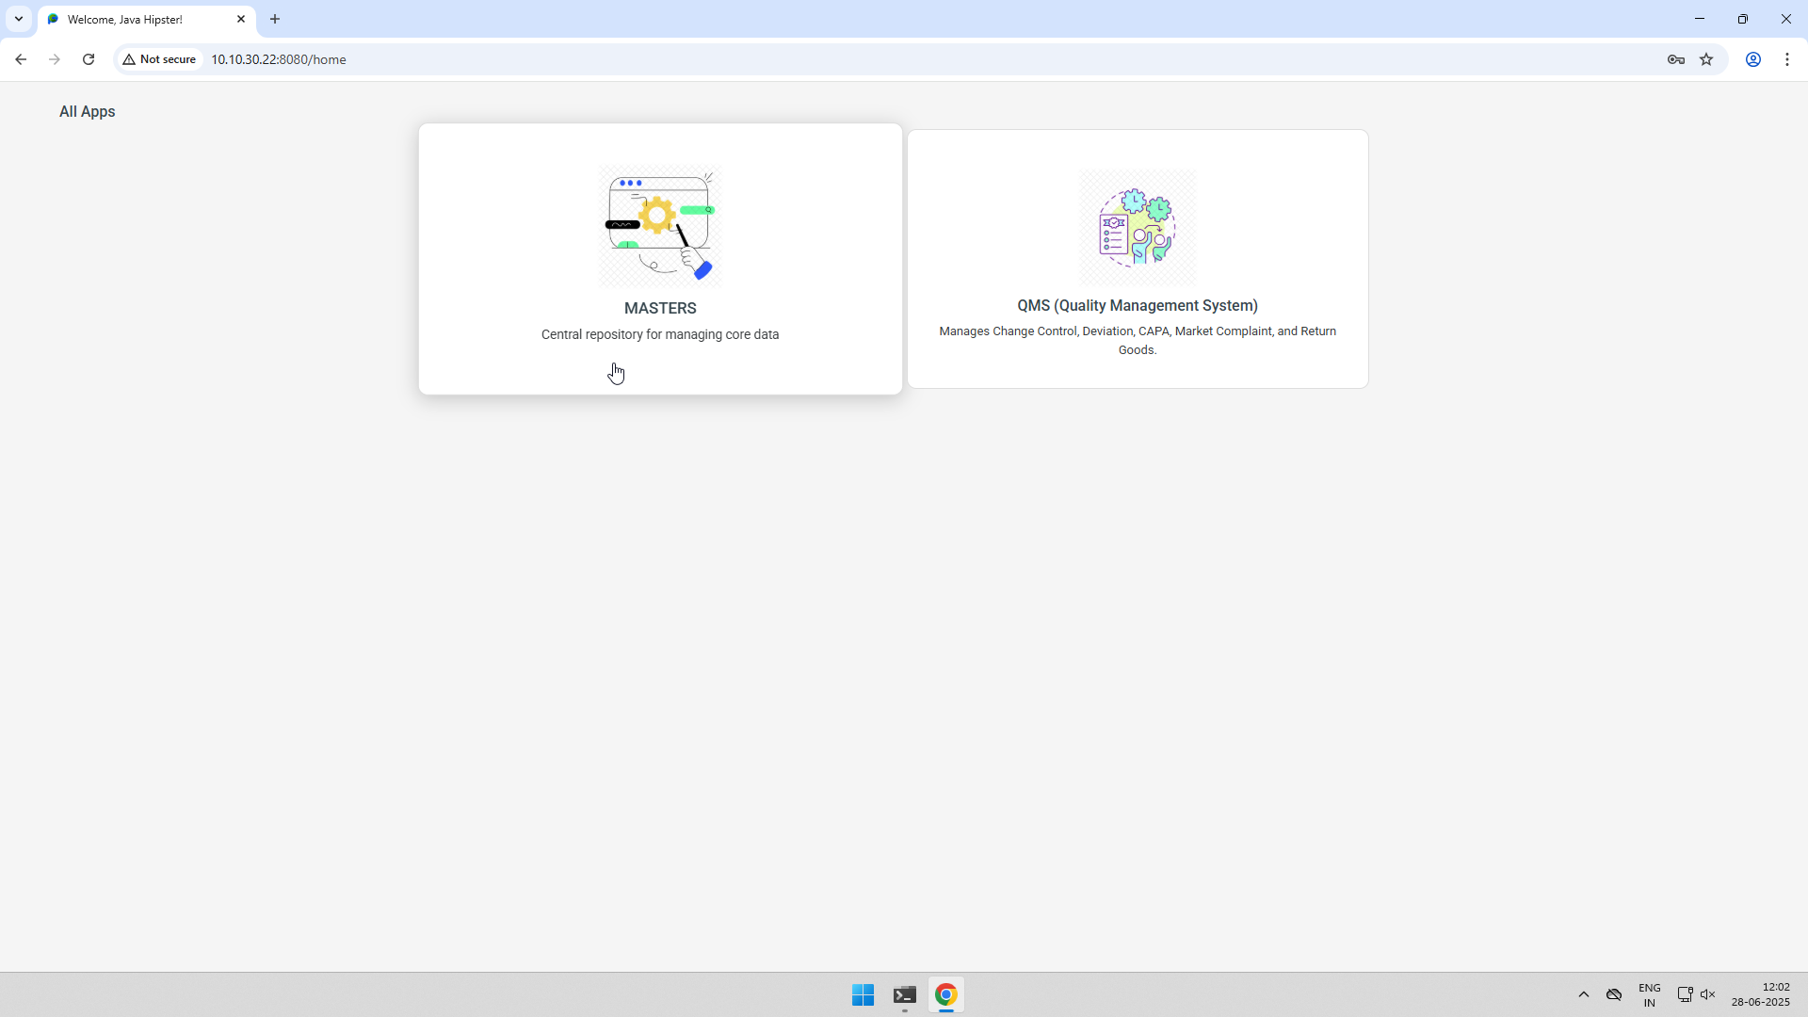
Screenshot No. 01 for step No. 4.4.2

Screenshot No. 02 for step No. 4.4.2
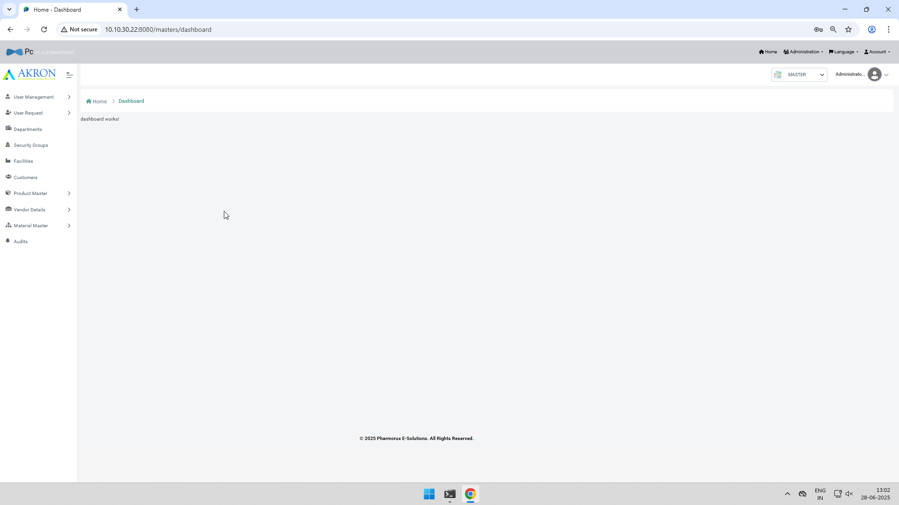
Screenshot No. 01 for step No. 4.4.3
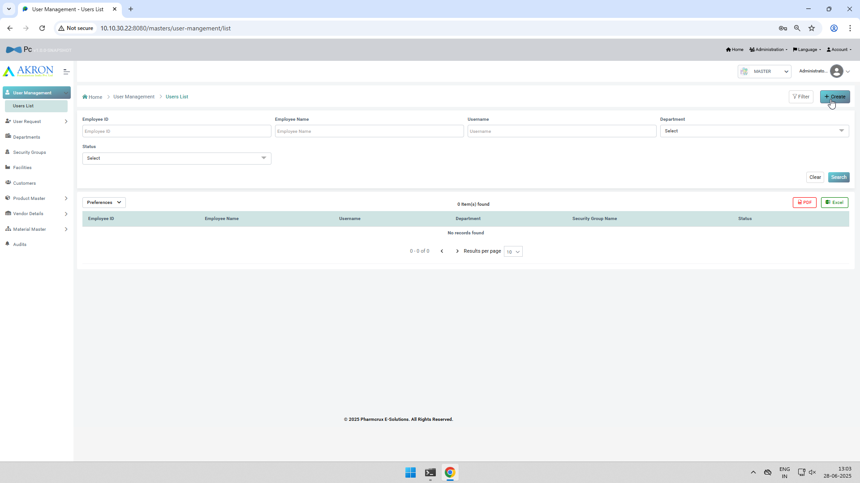
Screenshot No. 02 for step No. 4.4.3
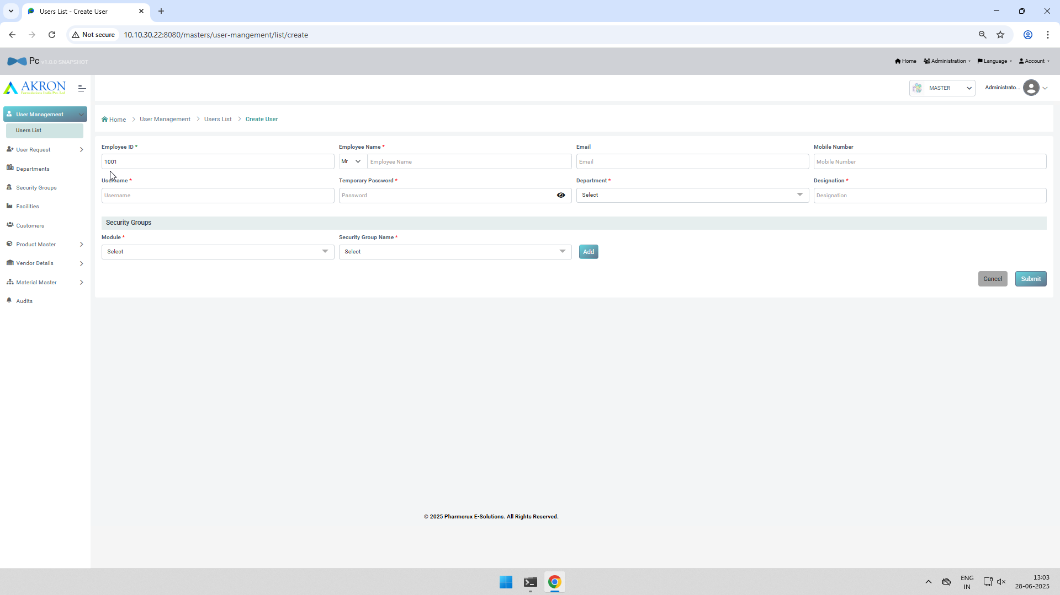
Screenshot No. 01 for step No. 4.4.4

Screenshot No. 02 for step No. 4.4.4
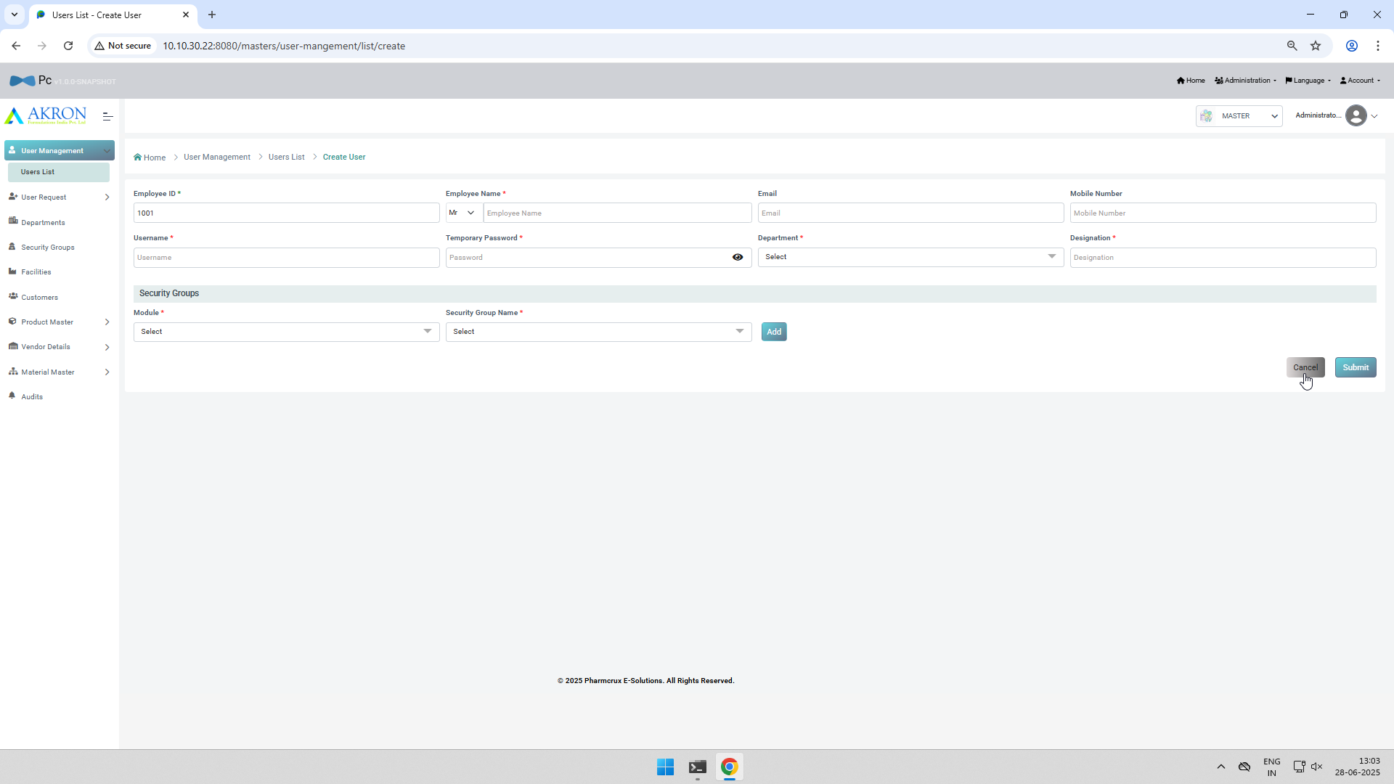
Screenshot No. 03 for step No. 4.4.4
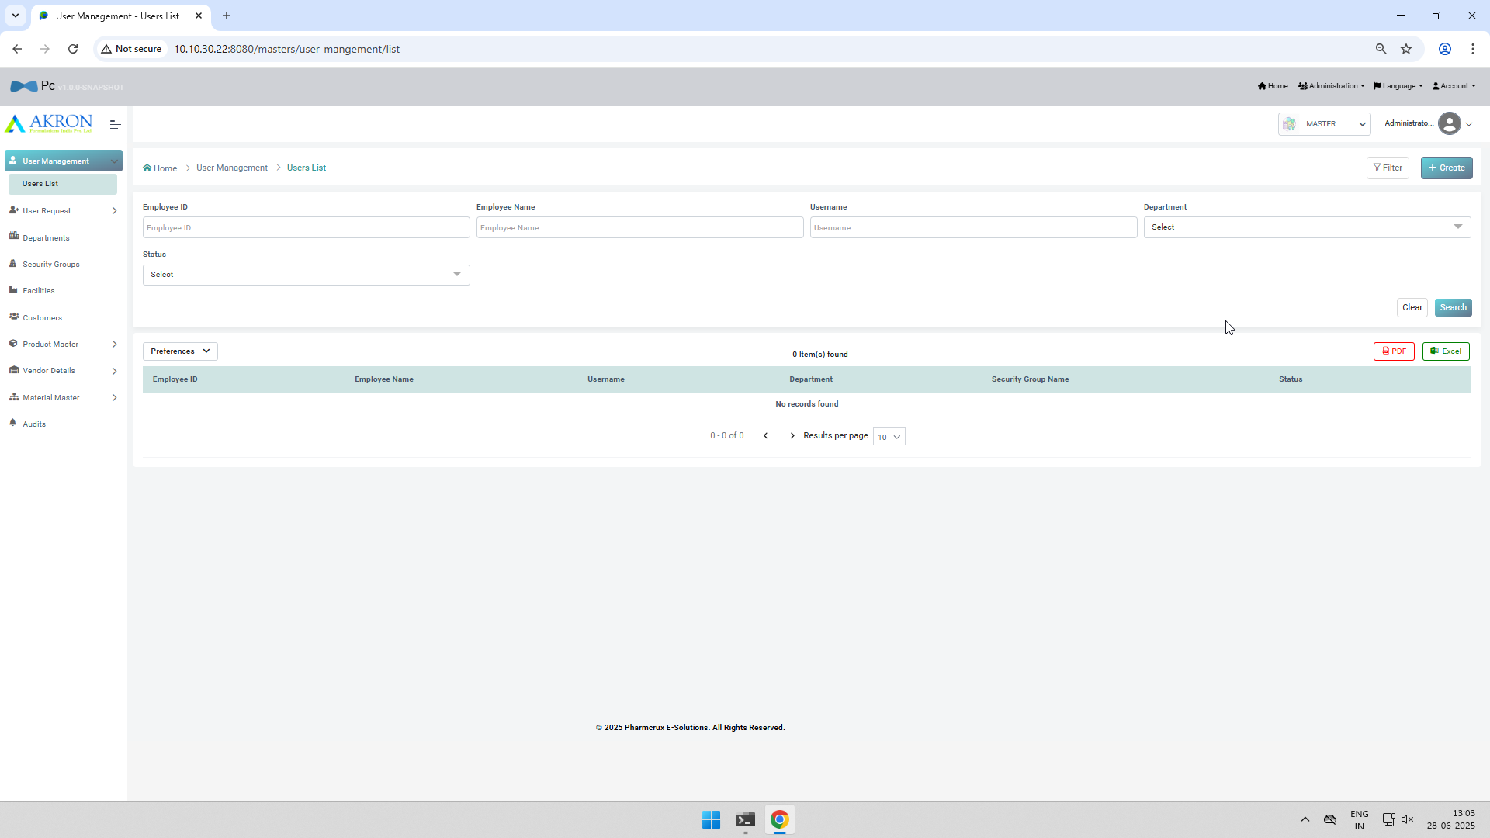
Screenshot No. 04 for step No. 4.4.4
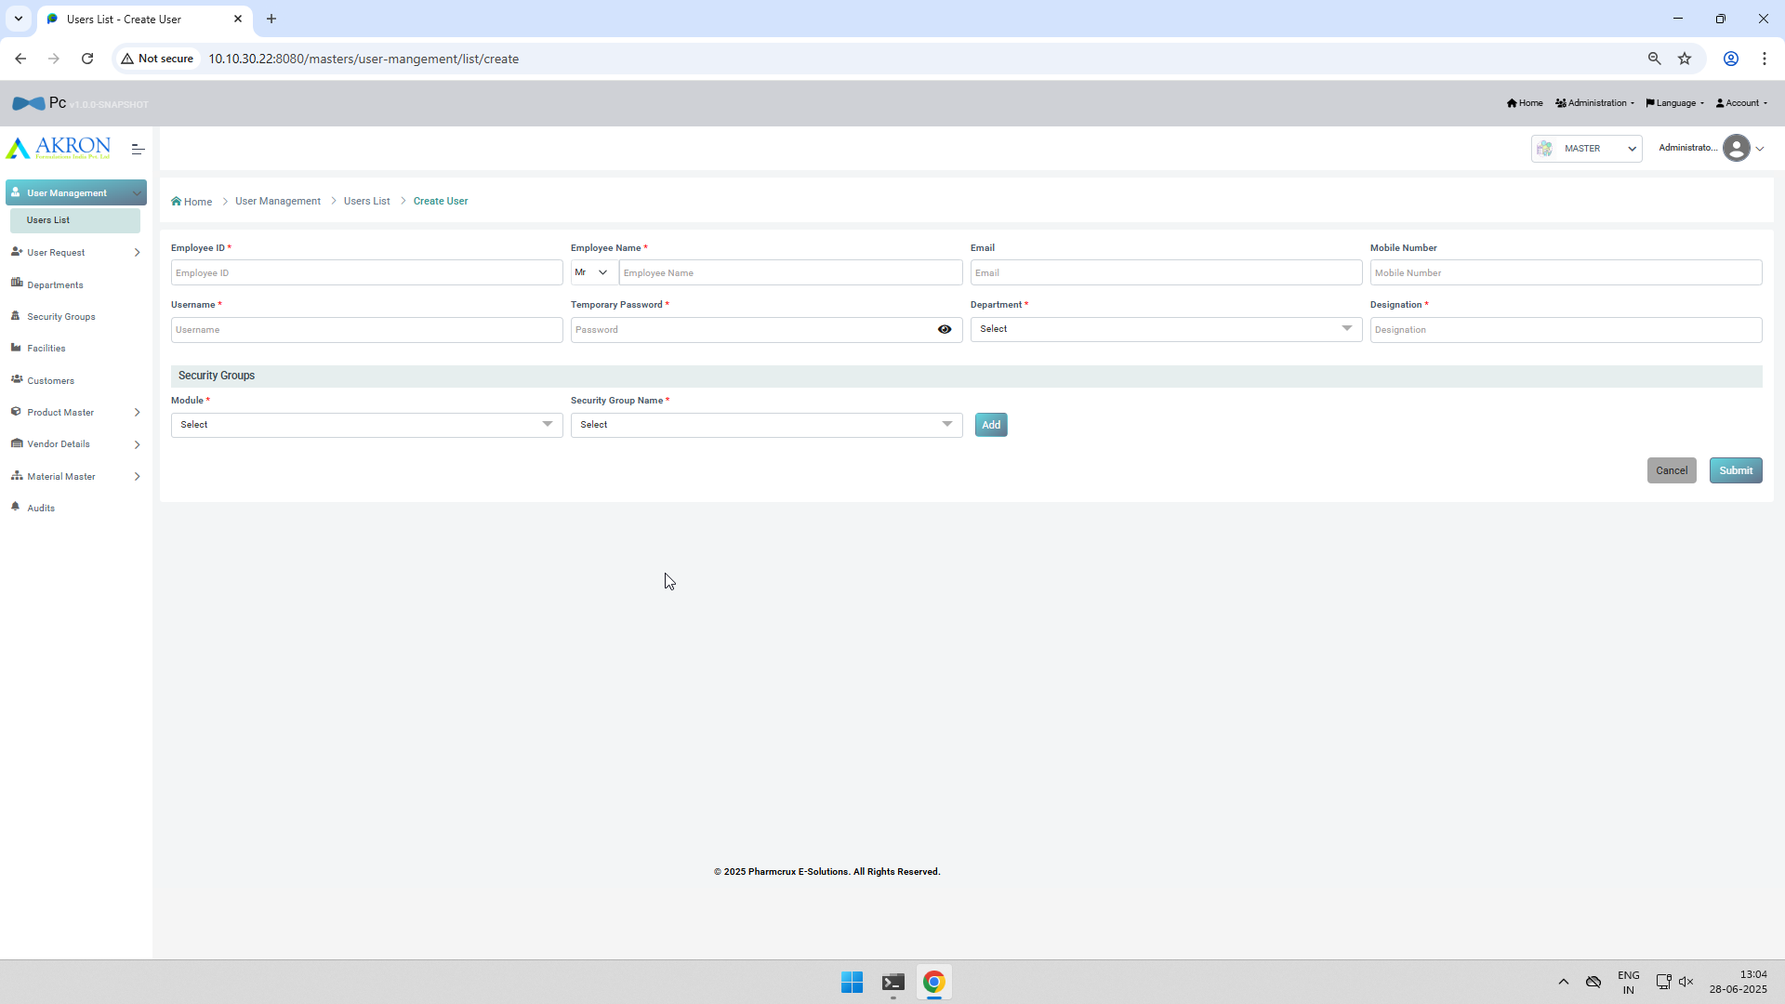
Screenshot No. 05 for step No. 4.4.4
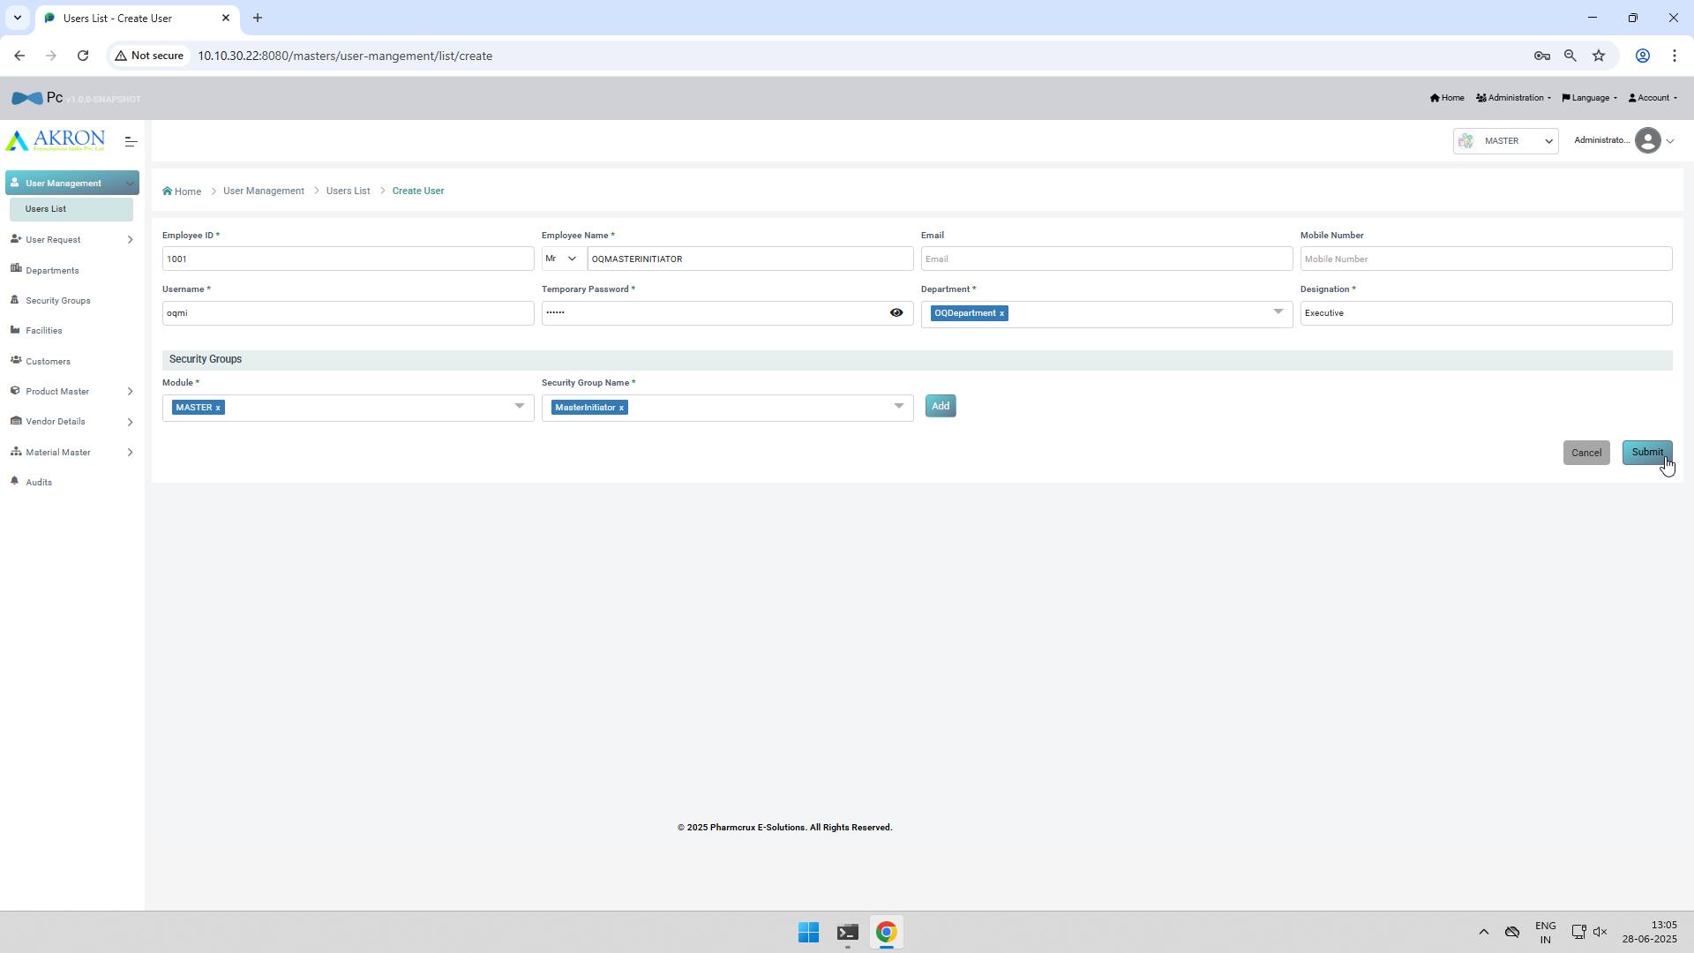
Screenshot No. 06 for step No. 4.4.4
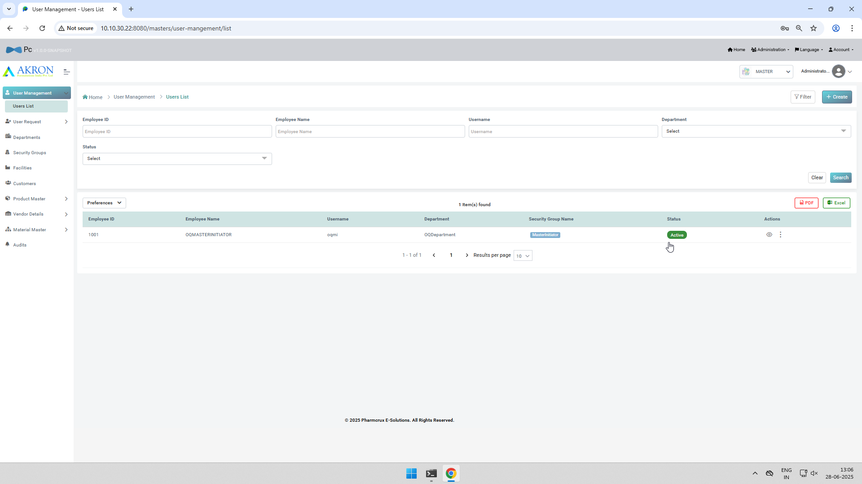
Screenshot No. 01 for step No. 4.4.5
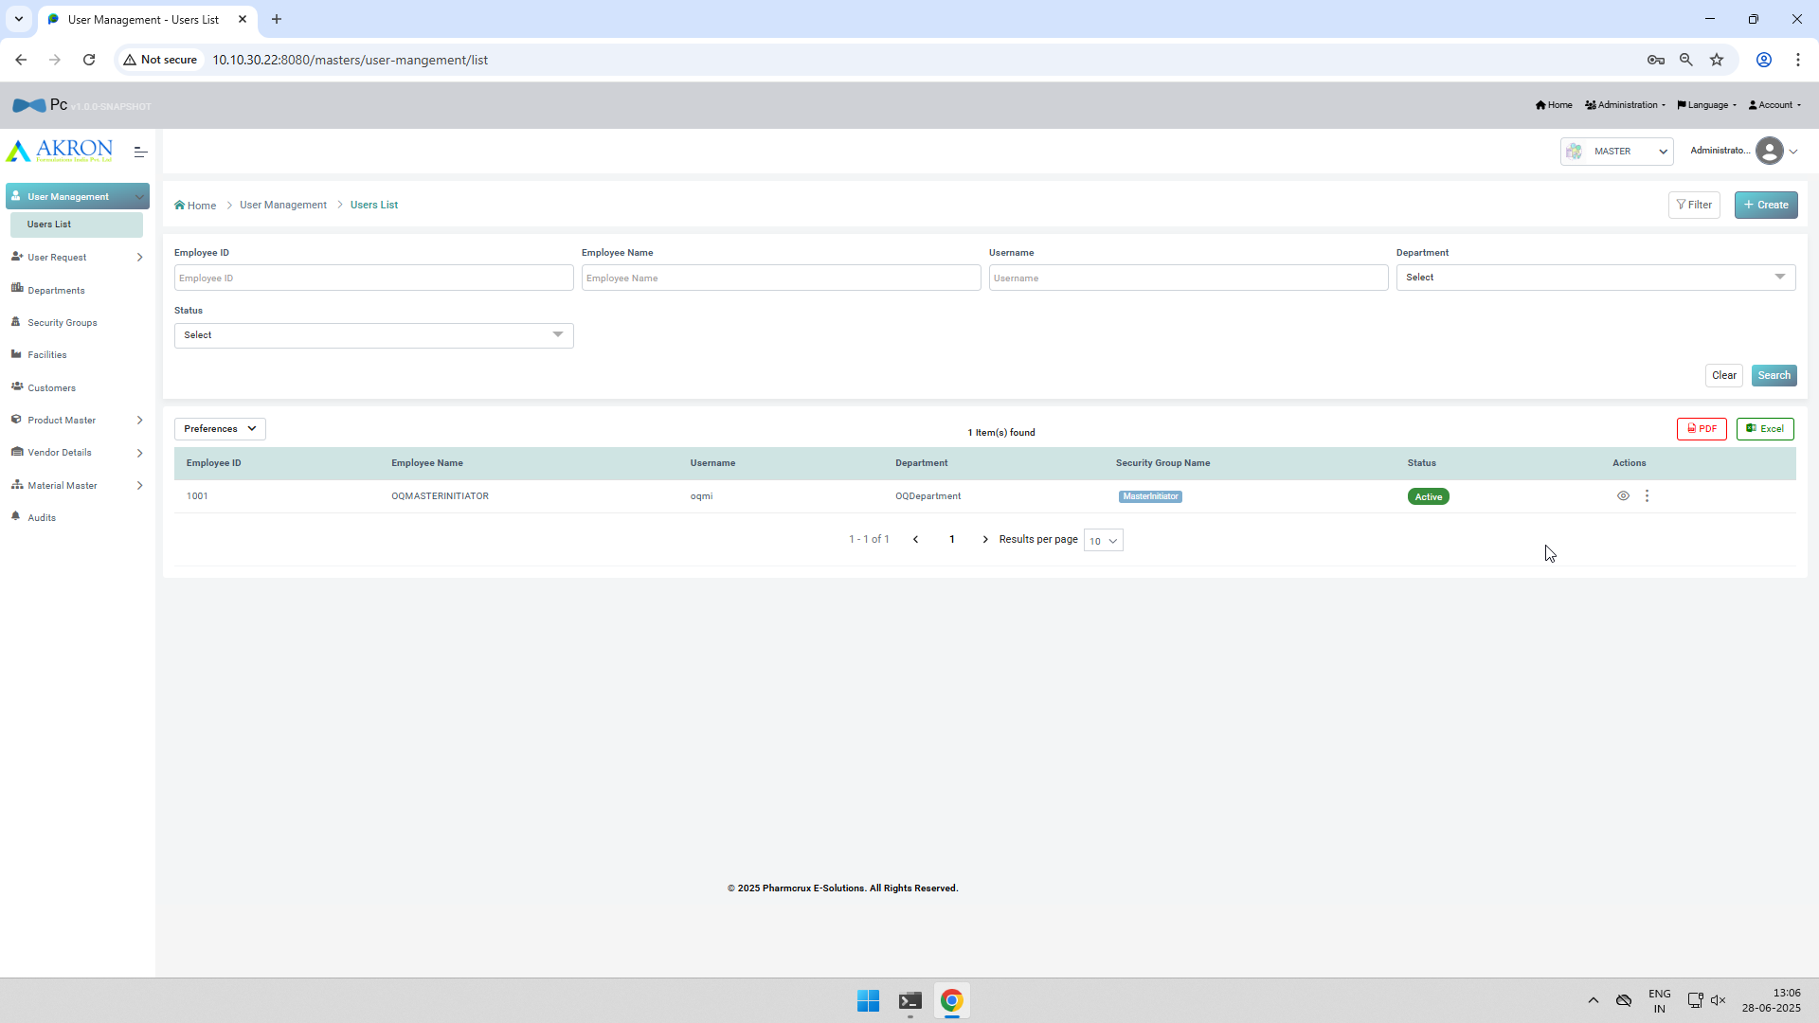

Screenshot No. 01 for step No. 4.4.6
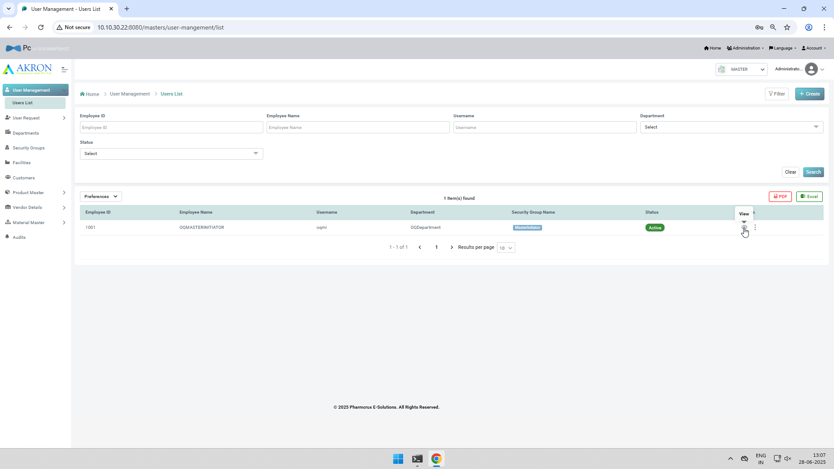
Screenshot No. 02 for step No. 4.4.6
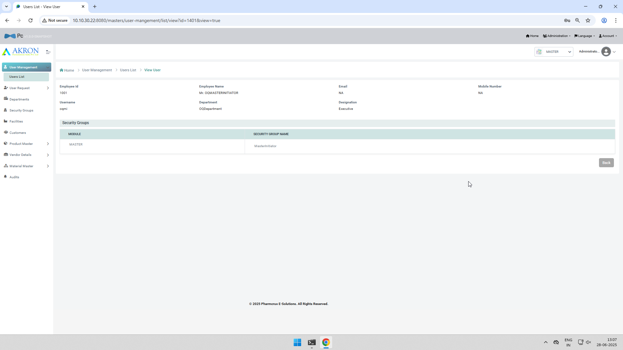
Screenshot No. 03 for step No. 4.4.6
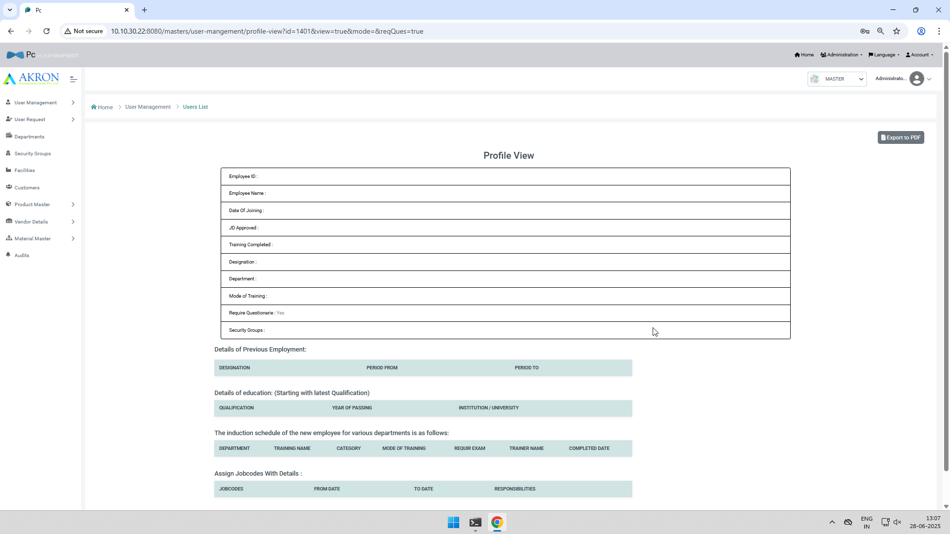
Screenshot No. 04 for step No. 4.4.6
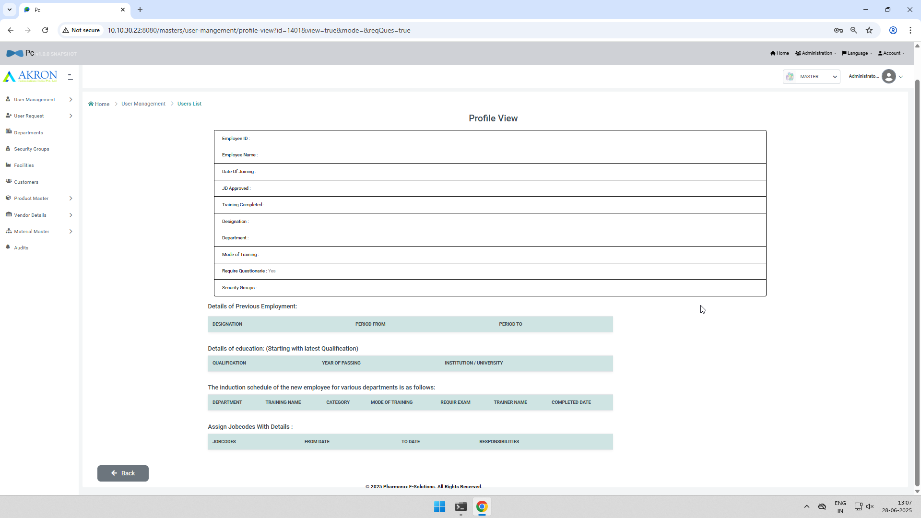
Screenshot No. 01 for step No. 4.4.7
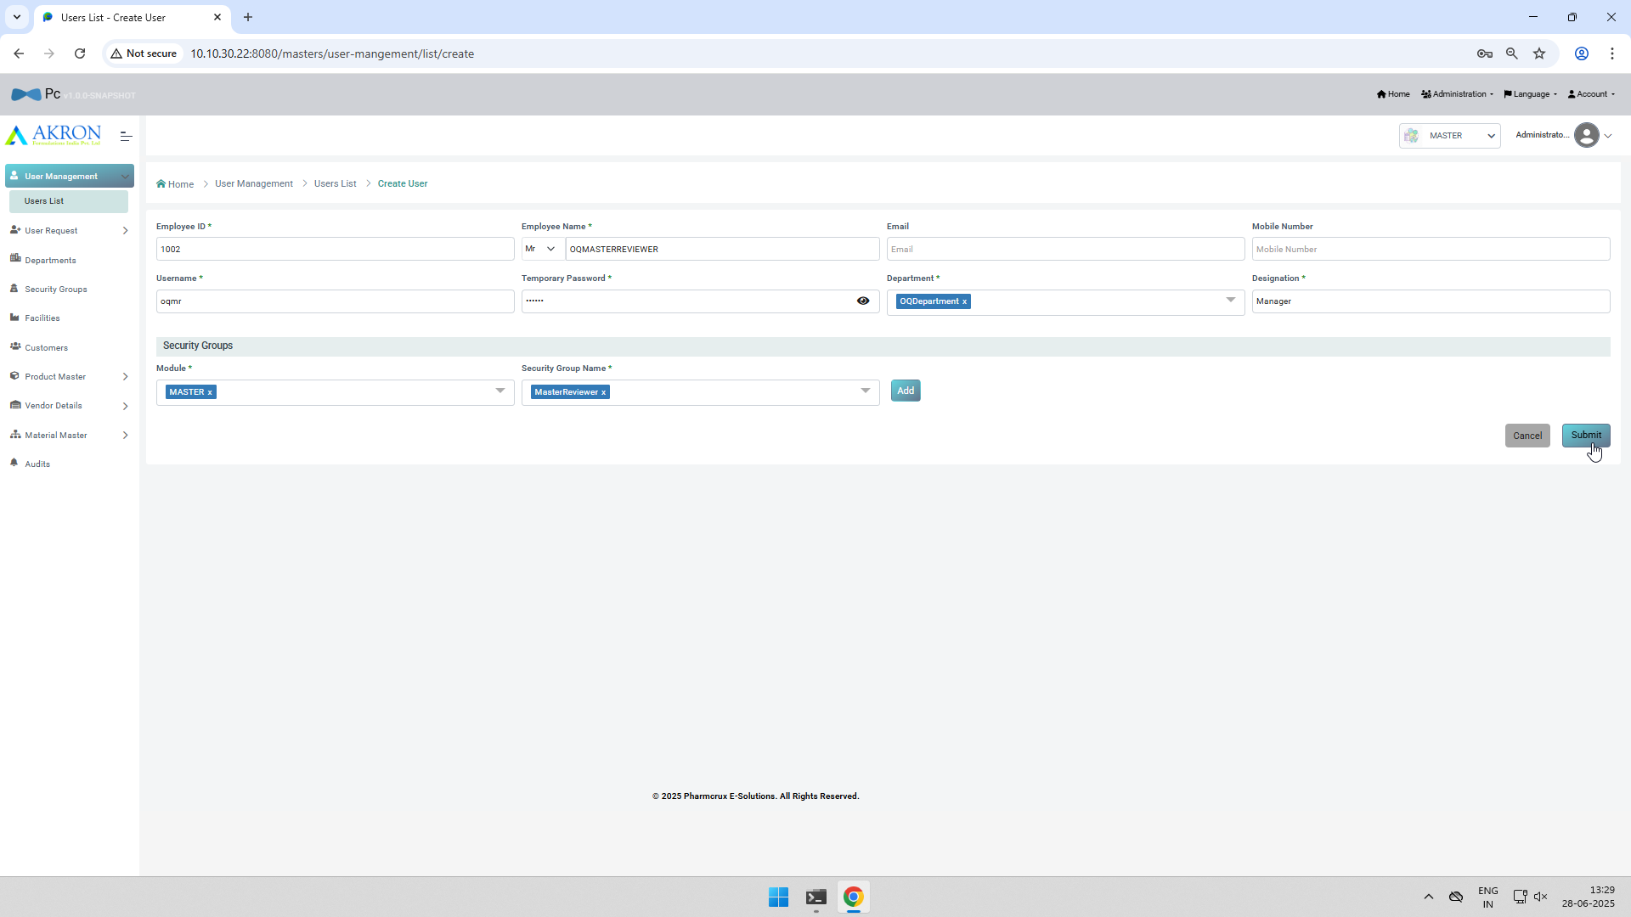
Screenshot No. 02 for step No. 4.4.7
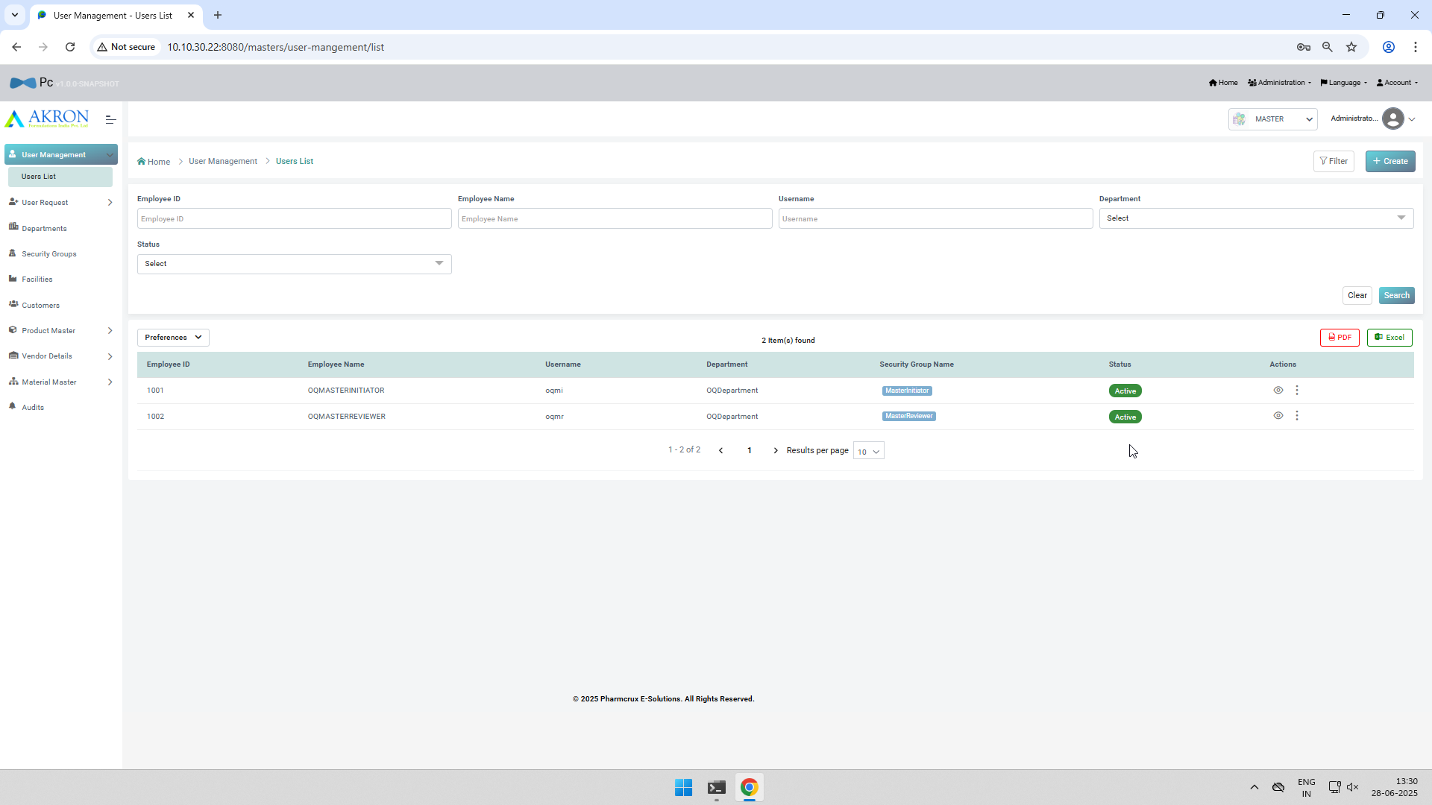
Screenshot No. 01 for step No. 4.4.8
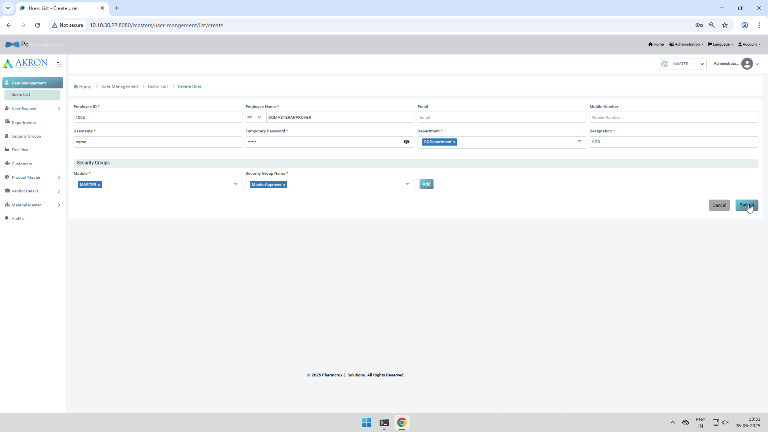
Screenshot No. 02 for step No. 4.4.8
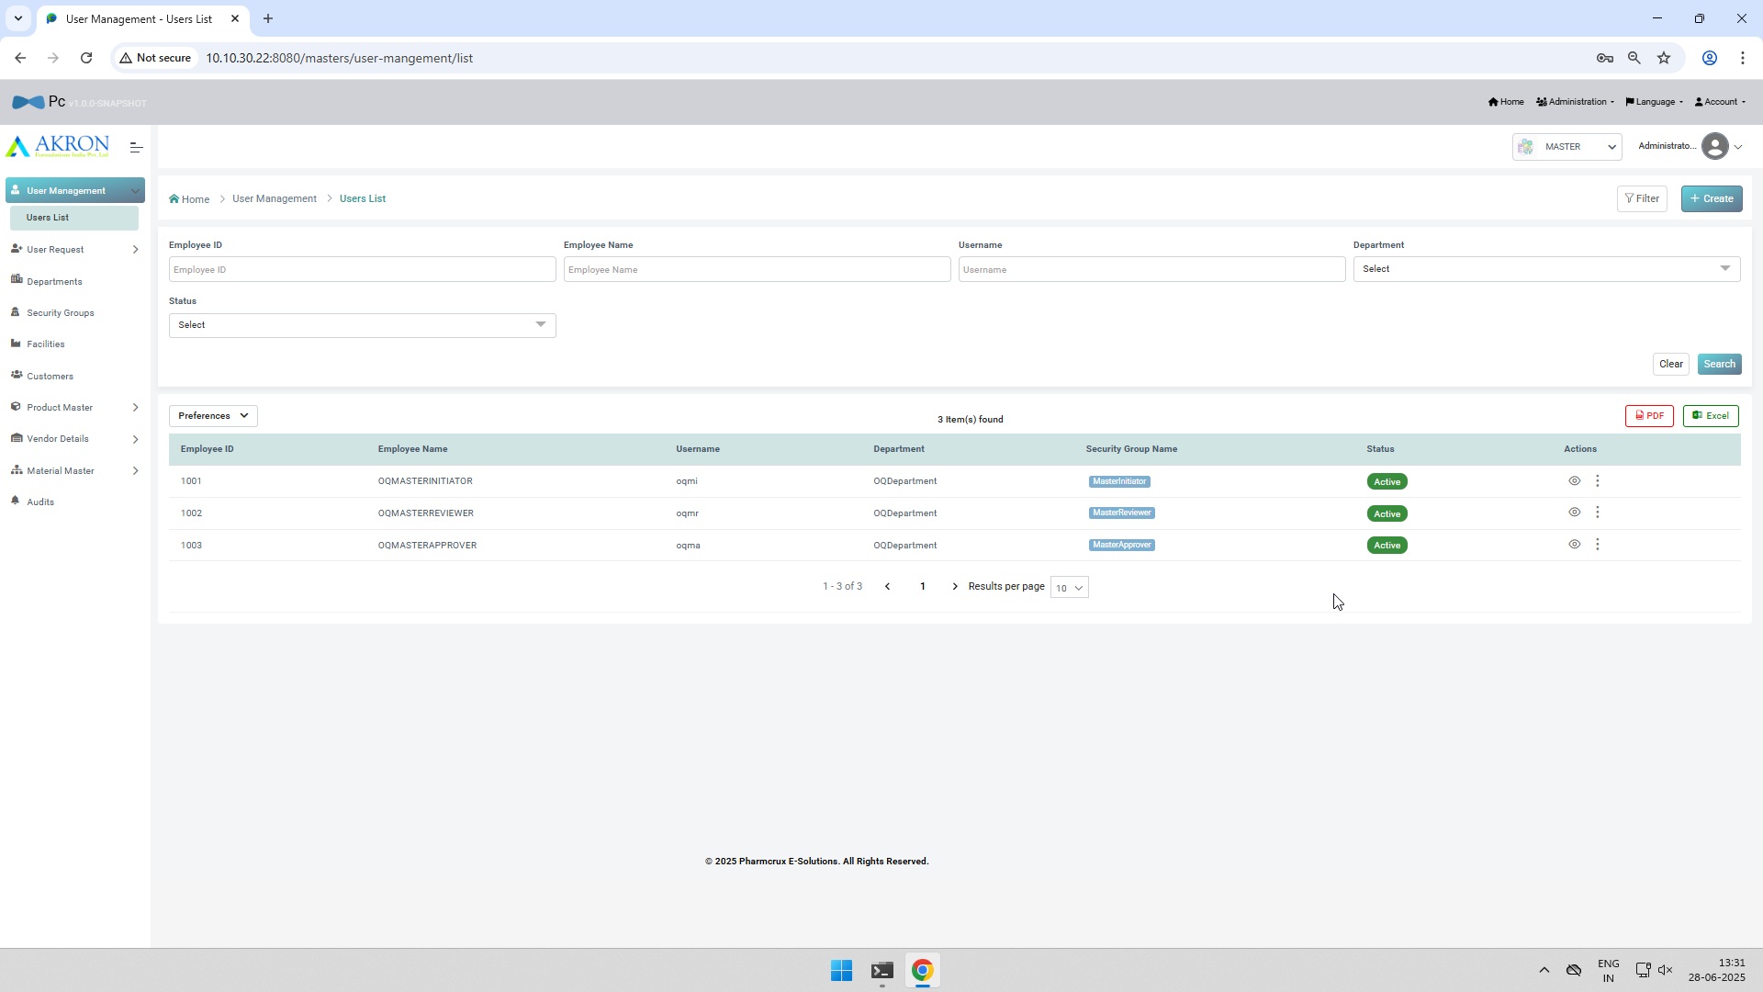
Screenshot No. 01 for step No. 4.4.9
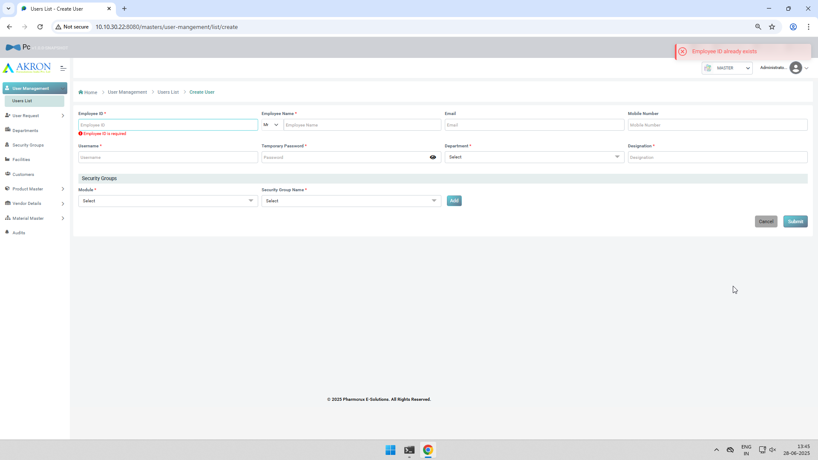
Screenshot No. 01 for step No. 4.4.10
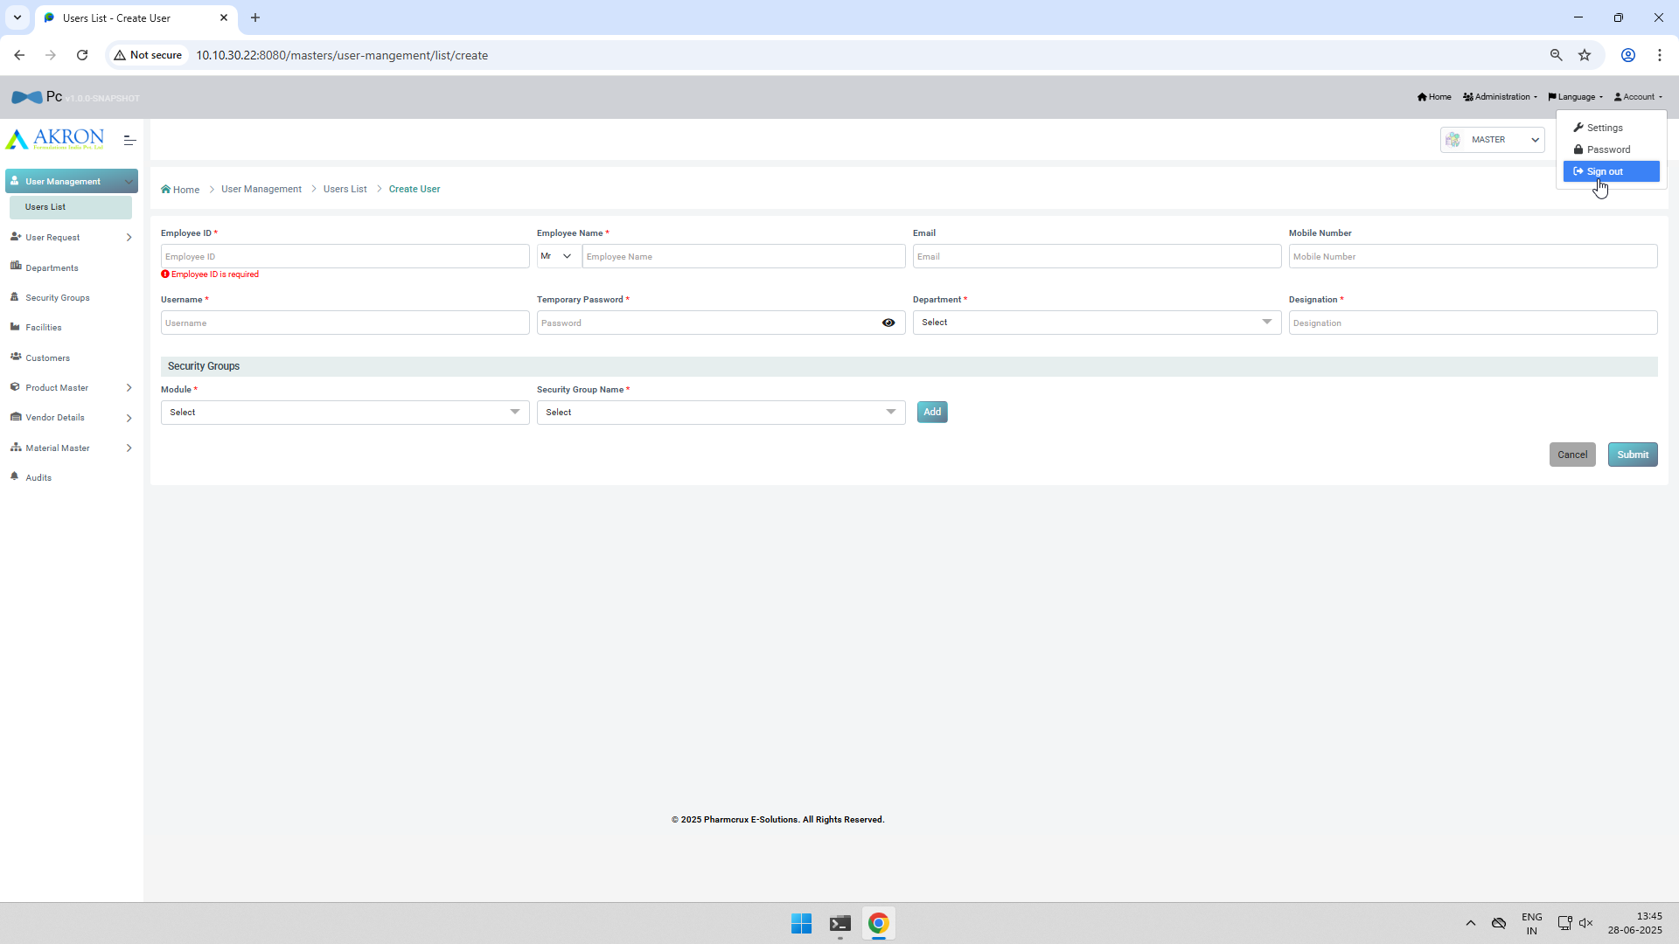
Screenshot No. 02 for step No. 4.4.10
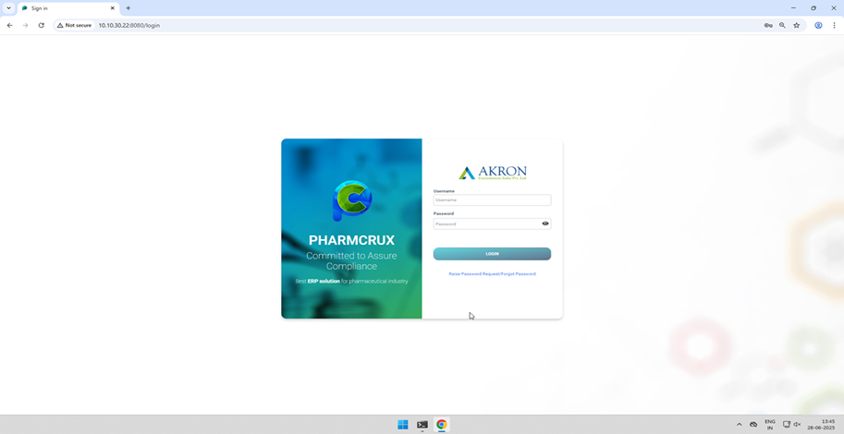

Test Duration Details: | Start Date: | 28-06-2025 | End Date: | 28-06-2025
 | Total Screenshots: | 30 | No. of Testers: | 1
Remarks:
A All The Test Cases Are Executed As Per The Test Script & Found Satisfactory. As Per Ref Document No : QMS-QSRV-OQTS-001
AsPe

Executed by
 | Name | Title, Department | Signature | Date

Reviewed By
 | Name | Title, Department | Signature | Date

Approved By
 | Name | Title, Department | Signature | Date

